424 Meeting 8

Hayes Griffin, Henry Meiring, Frank Jones, Ernesto de Losada,Nigel Malaba

**Power Test -- Shaft Failure**

* Drilled and tapped hole through coupling and shaft on generator side to bolt the two components together
* Fully functional pre-test; after startup sequence and a few seconds of operation the shaft from the gas engine side became unscrewed and flew off

**Shaft Redesign**

* Ordered materials to create new shafts
* New shafts designed to have: larger diameter, bolted connection (instead of threaded), solid cross-section, and a longer keyway
* Proceed with Lovejoy coupling

**Mounting Preliminary Design**

* Preliminary design combines aluminum bars (torque resistance) with carbon fiber tubes (weight) to mount three MG-sets parallel to one another in the approximately 10.5” space between the “6-pointed star” top level and the new base

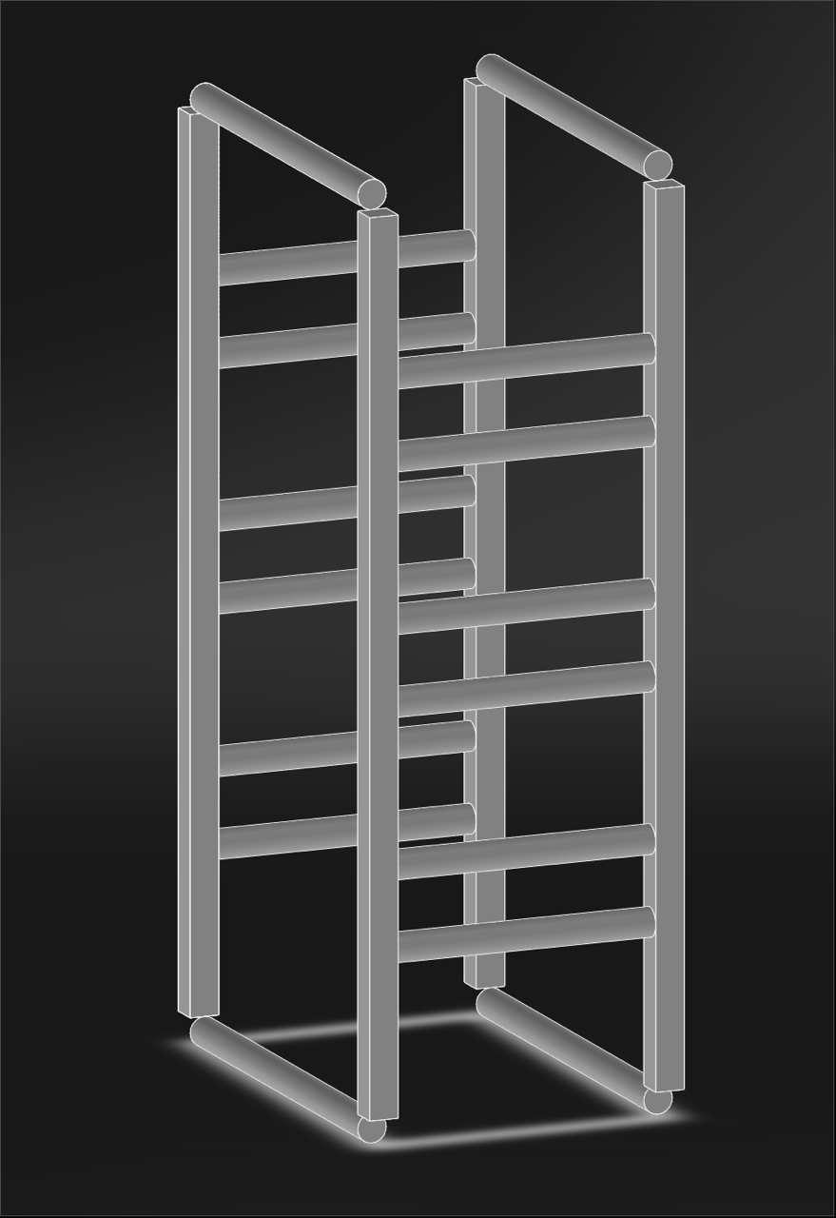

***Drone Body and Frame Design***

* Original base design (lacking in structural strength):
  + Isometric: Side View:

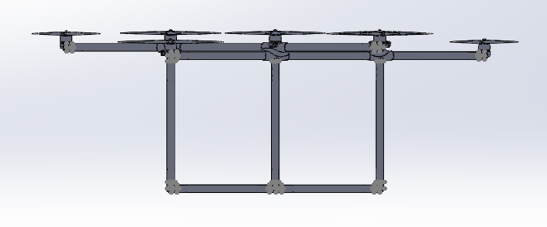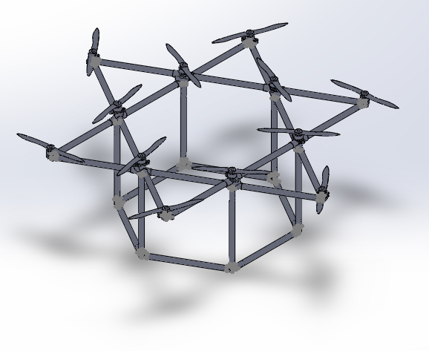

* Complete redesign of hexagonal base:
  + Isometric: Top View: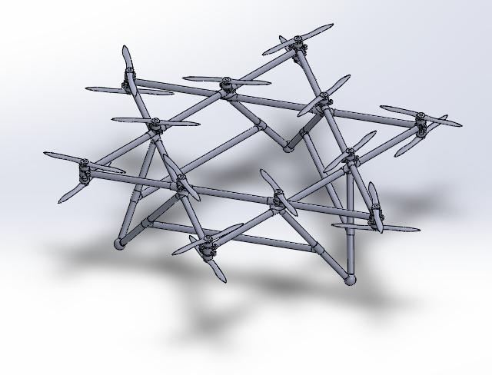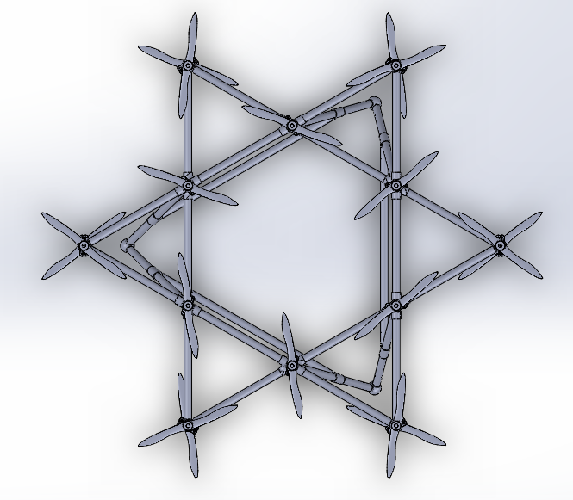

* + Side View:

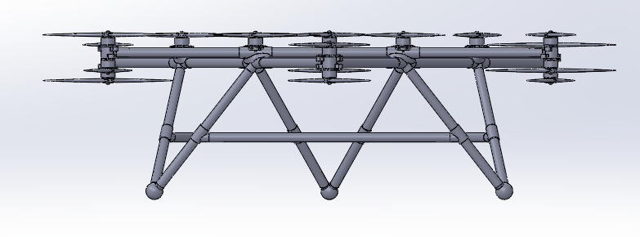

* + Updates:
    - The joints are currently being printed and will be ready for assembly
    - The sides of the base will be made of carbon fiber piping, the same tubing used in the main upper body of the drone
* Electronics baseplate
  + Three carbon fiber rods will come together at the center of the hexagon to support a baseplate that will be 3D printed
  + The plate will have a grid of holes in order to allow for the electronics to be securely and evenly attached
  + Constraints: High stability and minimum area required
  + Objectives: Minimize area (weight) while maintaining stability for flight systems

